Linux Task

Create user with name Techie and provide sudo access to user.

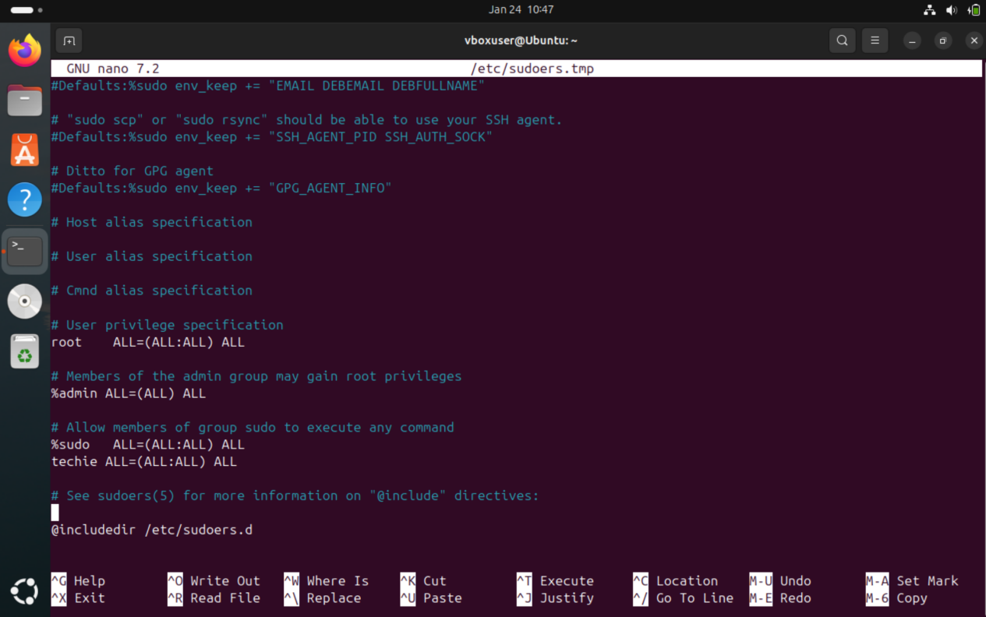

Navigate to the home directory.

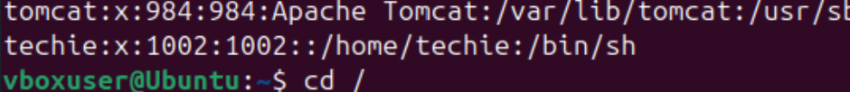

Create a new directory.



List the contents of a directory.

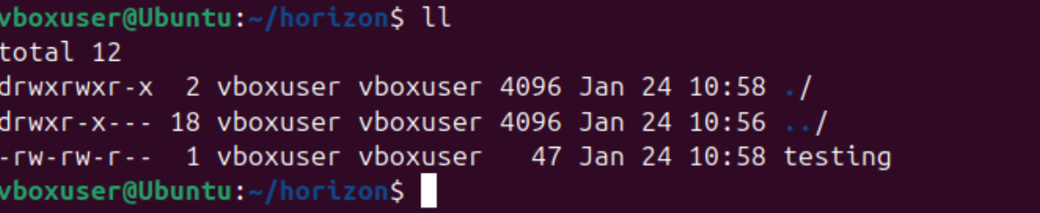

Change the current directory.

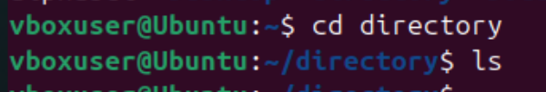

Create a new empty file.

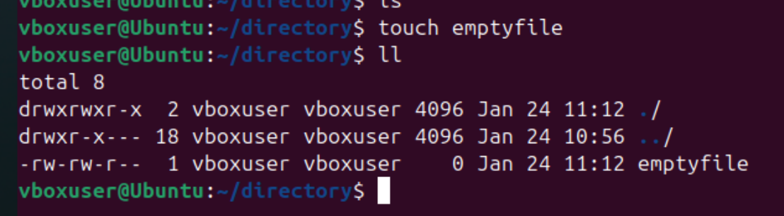

View the contents of a file.

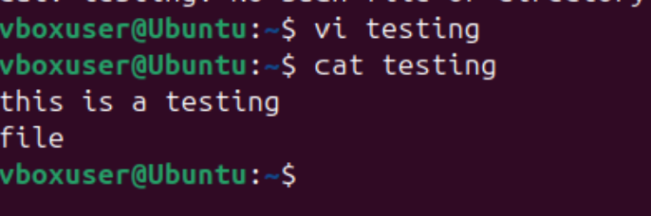

Copy a file to another location.

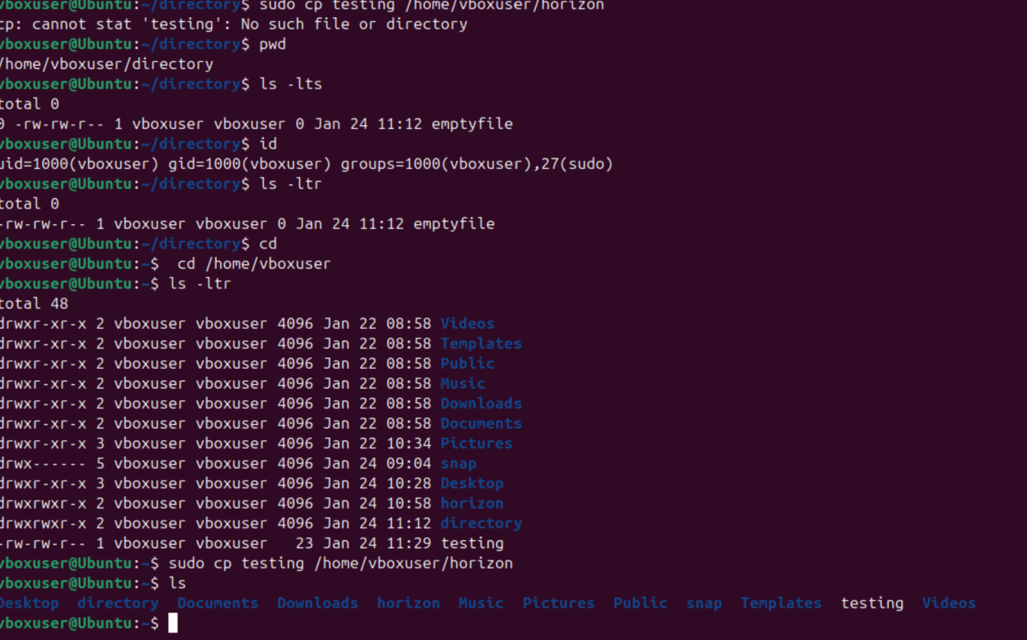

Rename a file

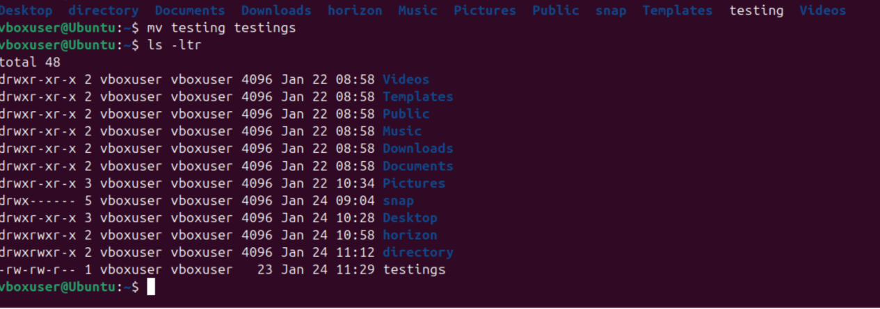

Delete a file.

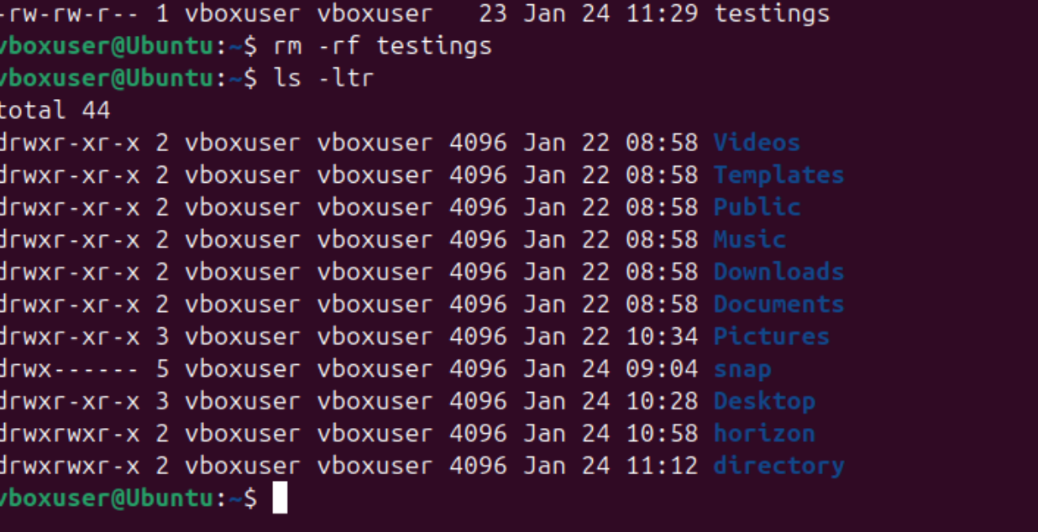

Grant or revoke permissions on a file or directory.

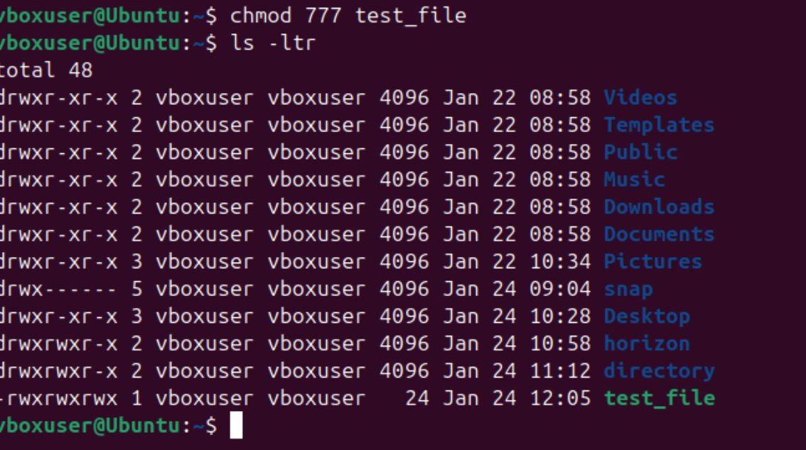

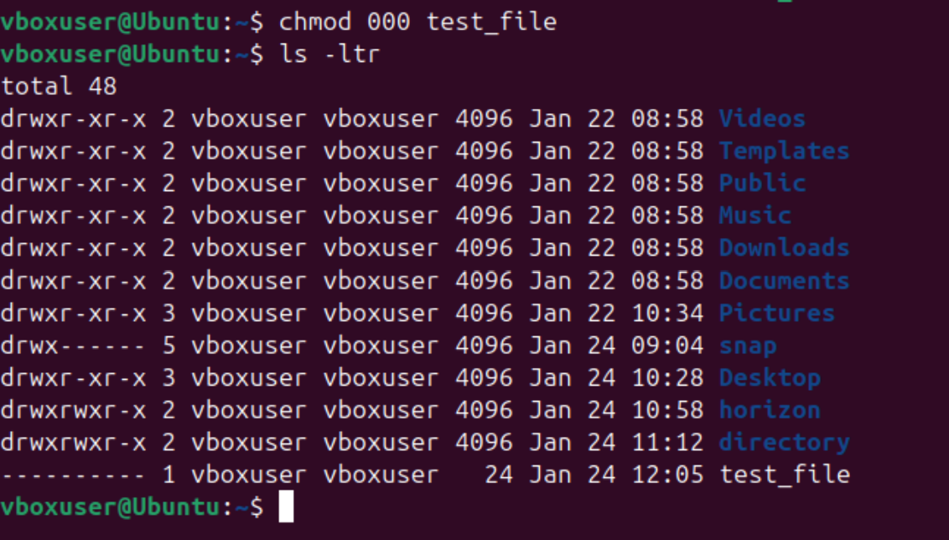

View the current date and time.

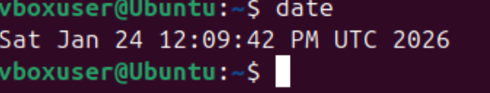

Check the system uptime.

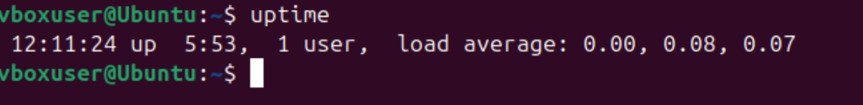

View the running processes.

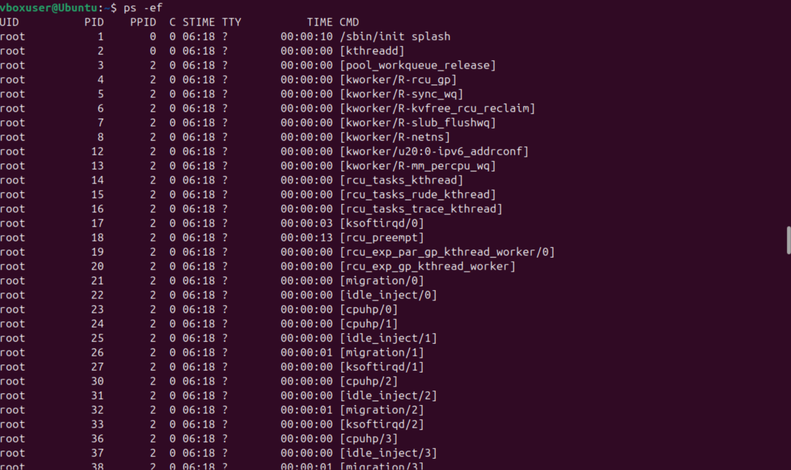

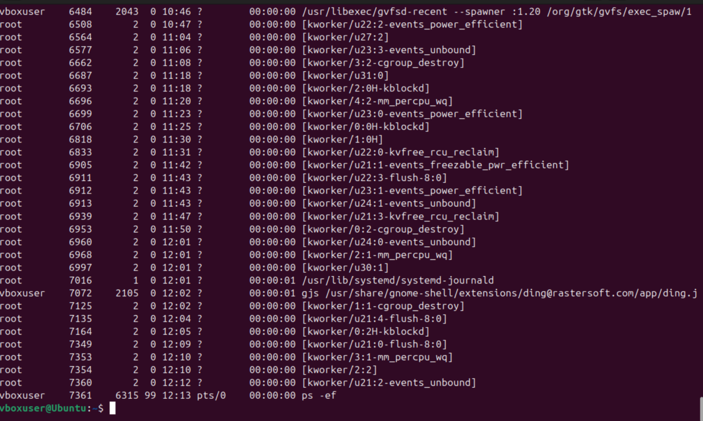

Kill a running process.

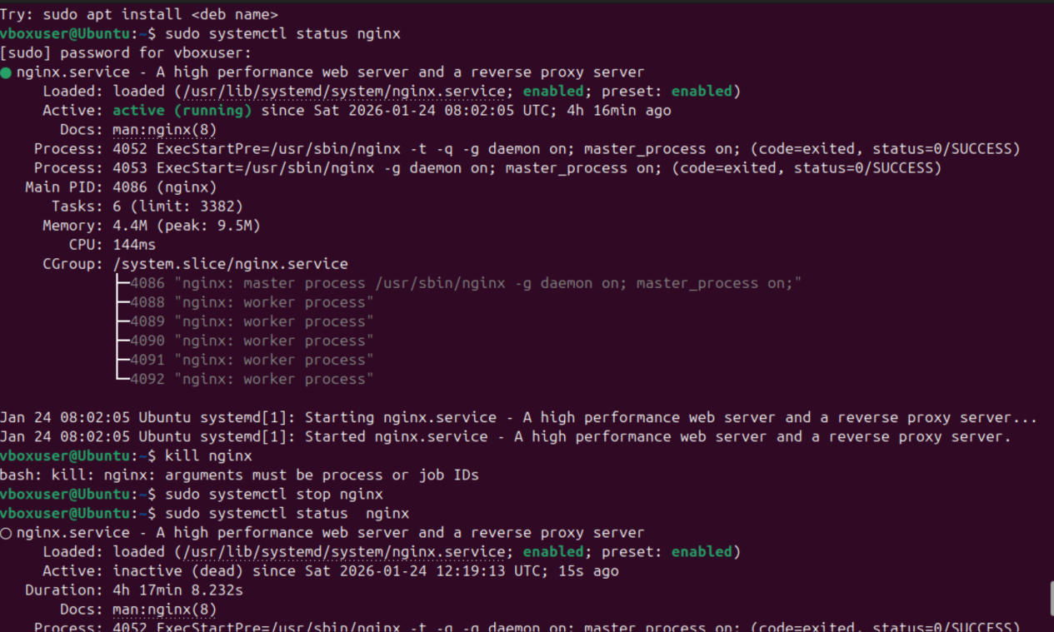

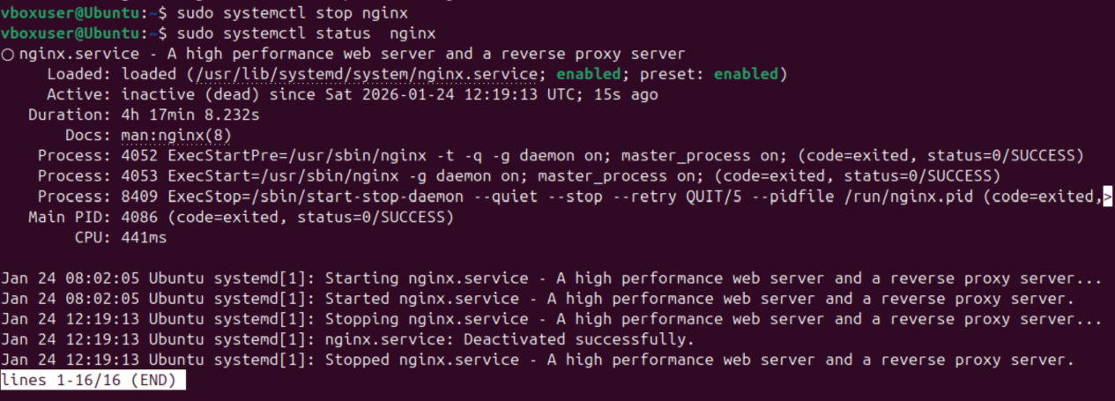

Install a package using the package manager (e.g., apt or yum).

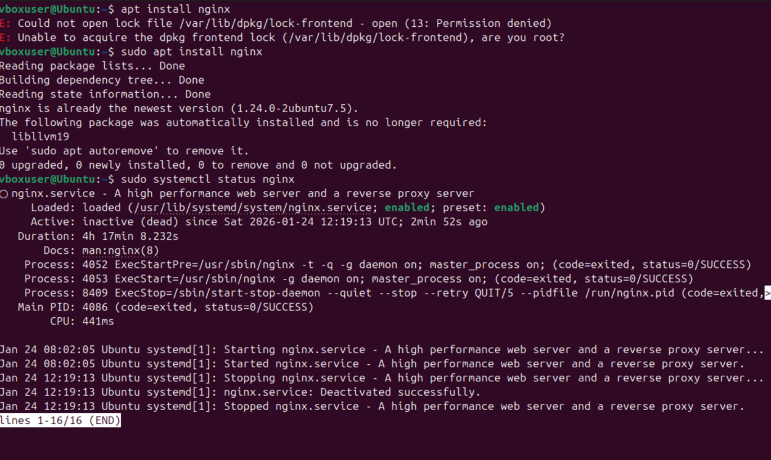

Update the system packages.

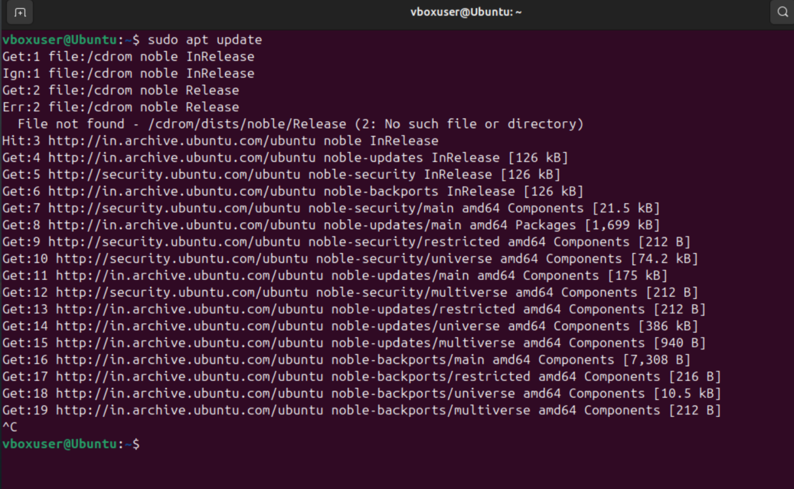

Create a symbolic link

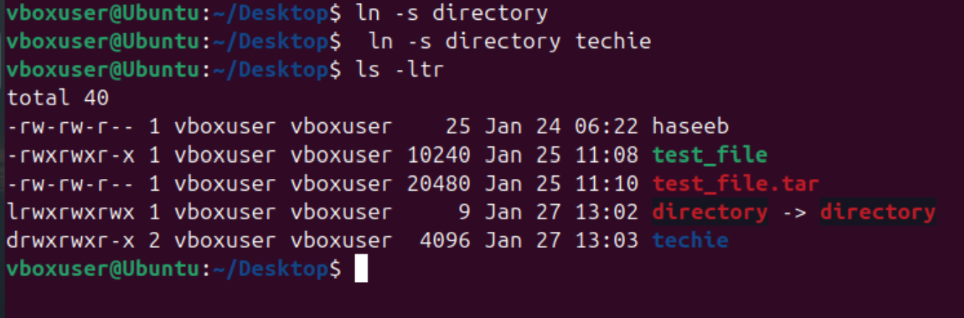

.

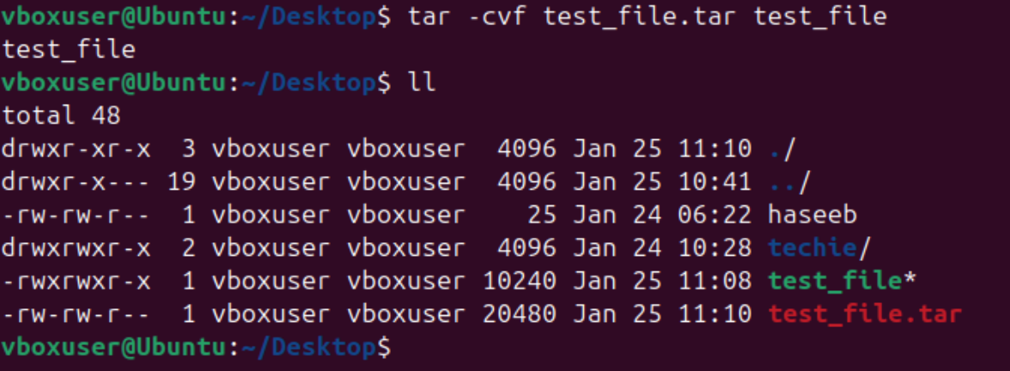

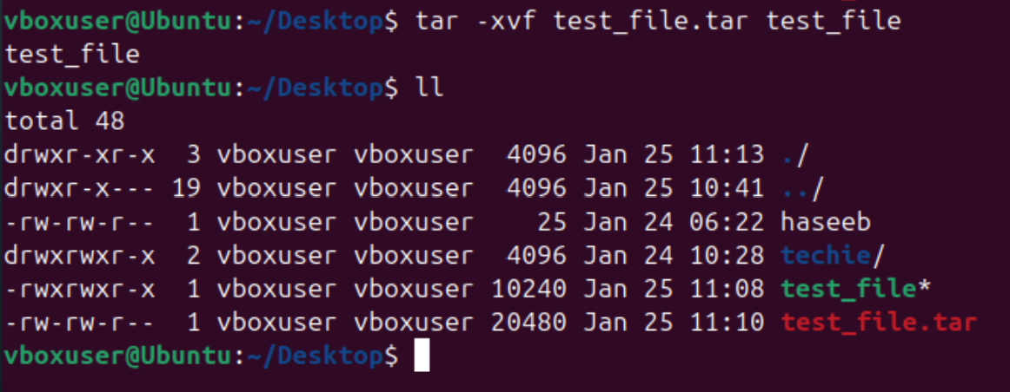

Mentioned system resources with top or htop

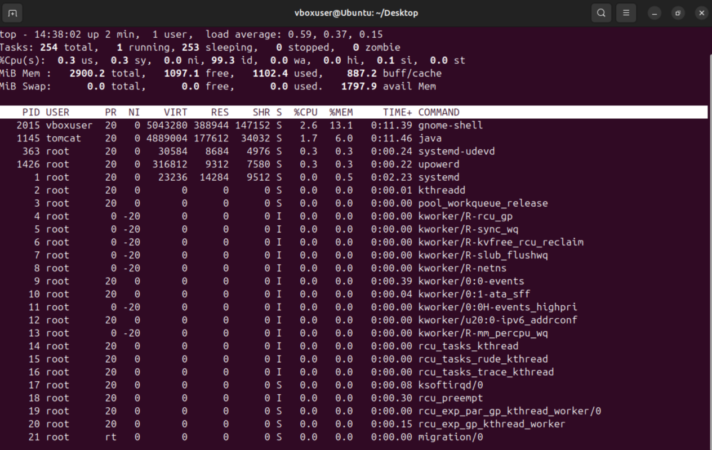

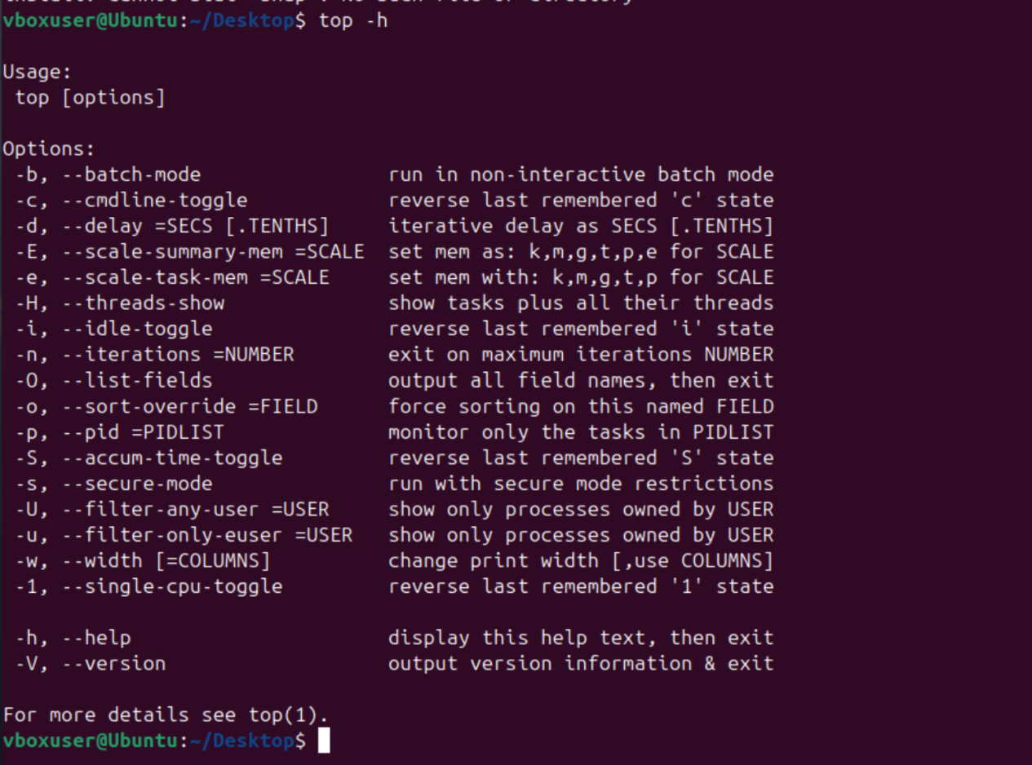

Create and manage user groups

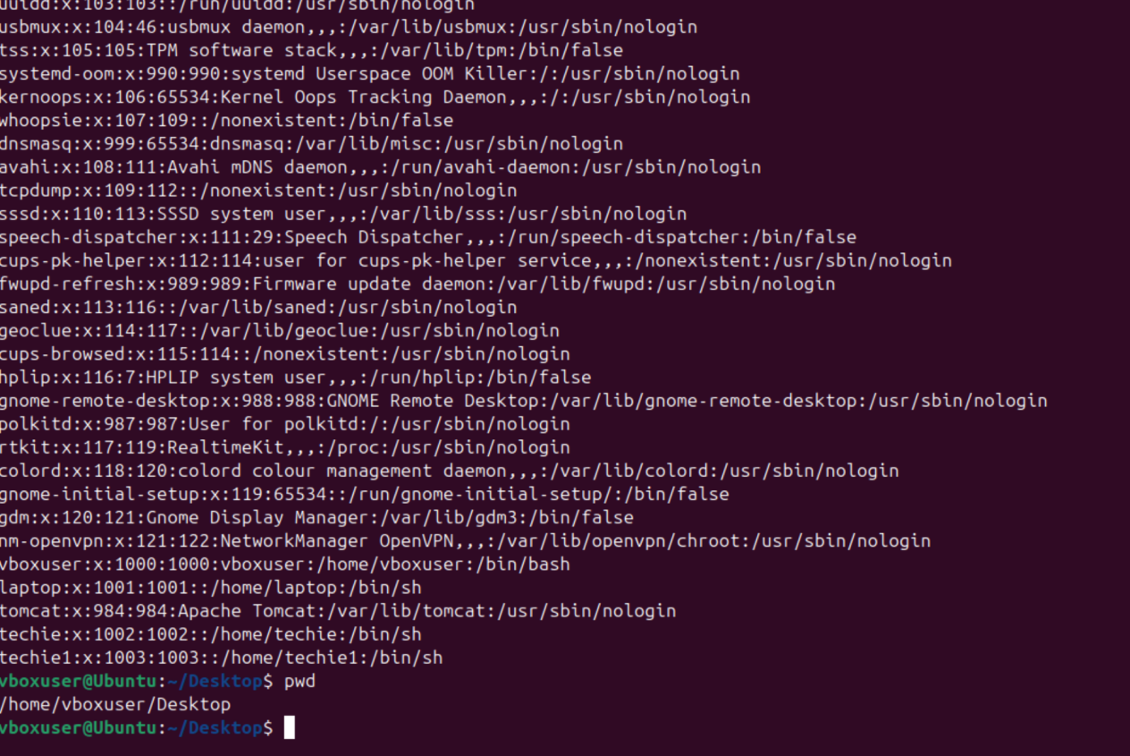

**Setup a SSH password less authentication**

First step is ssh-keygen, it will ask to select the file to save the key they give the password.

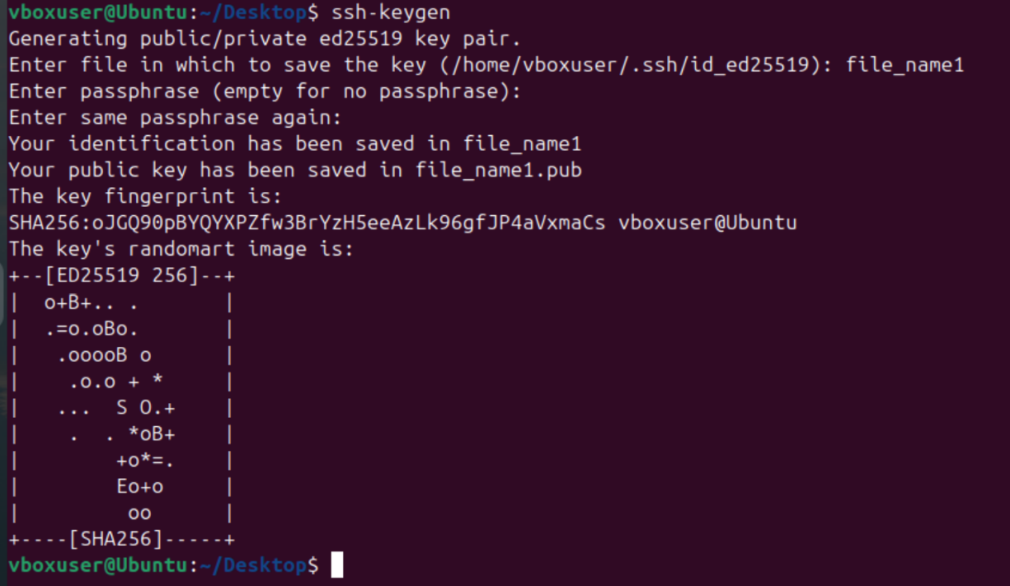

(Incomplete)

Monitor log file using tail or grep

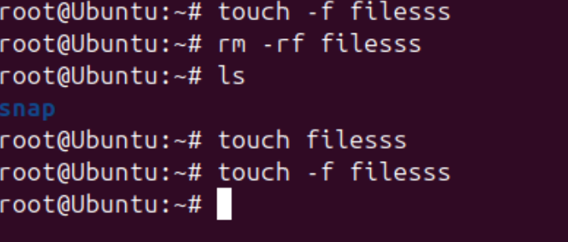

Setup a webserver (eg., apache or nginx)

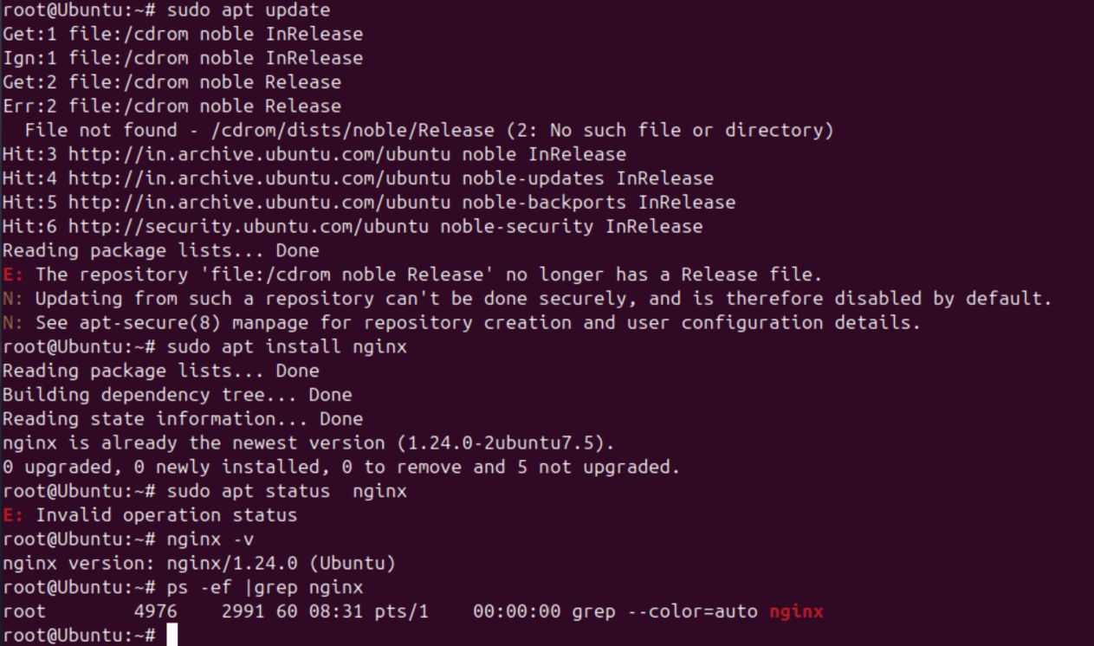

**Configure and secure MYSWL Database**

Google mysql and click on first link.

Download for windows.

Open the application after downloaded

Click on custom installation

Click on next

Check first option called install for all users

Click on next and installation begins..

Click on close after installing successfully.

We need to install mysql server , workbench and shell

Search mysql on google

Click again on the first link

Click on downloads, on the bottom of the page we see an option called Mysql community gpl downloads, click on it.

Click on installer for windows, click on 64bit download option.

Installation begins, click on custom installation.

Click next and need to select the products from the list by cliking on the option (+) and hit next and click on Execute.

Click next, next, enter strong password and if you need to add a user you can click on add user and clico on next.

Click on Execute.

Now we need to give path where mysql app has been installed on our computer. We need to copy and paste it in the option called Environment variables you will find this in start option of the windows.

Open the option click on advanced, environment variables, path, click on new and paste the same path. Then click OK.

To check if the mysql has been installed properly, hit the command prompt in the windows > mysql - version

Mysql -u root -p (U user P password)

Enter the same password which been set. Hit enter.

Updated succesfully.

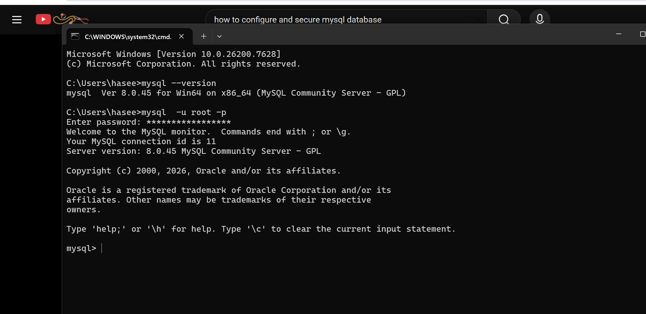

**Setup an application server eg., tomcat .**

**Search Tomcat on Google**

**Open first link, and go under Binary Distributions**

**Look for 64-bit windows zip pack.**

**Click on it and it gets downloaded, run the downloaded link and do the basic installer and before downloading the tomcat make sure the java is installed in the computer first.**

**Then go to start and search for “Services” to check if the tomcat being installed successfully.**

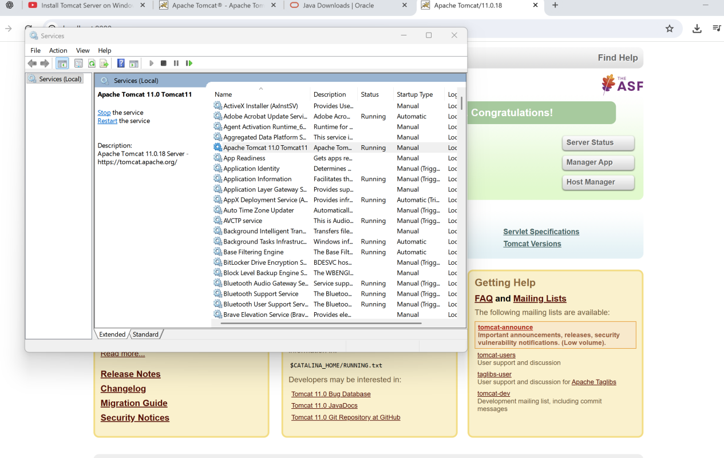

**create a service file for Apache Tomcat.(Should execute by using systemtctl command)**

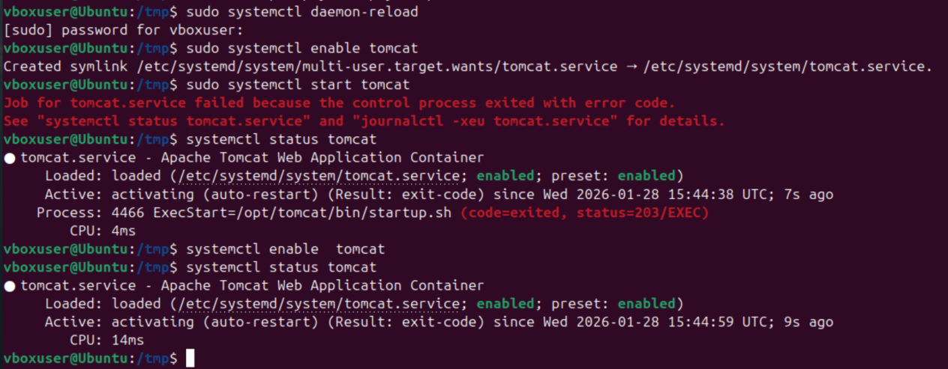

**Print specific columns from a delimited file.**

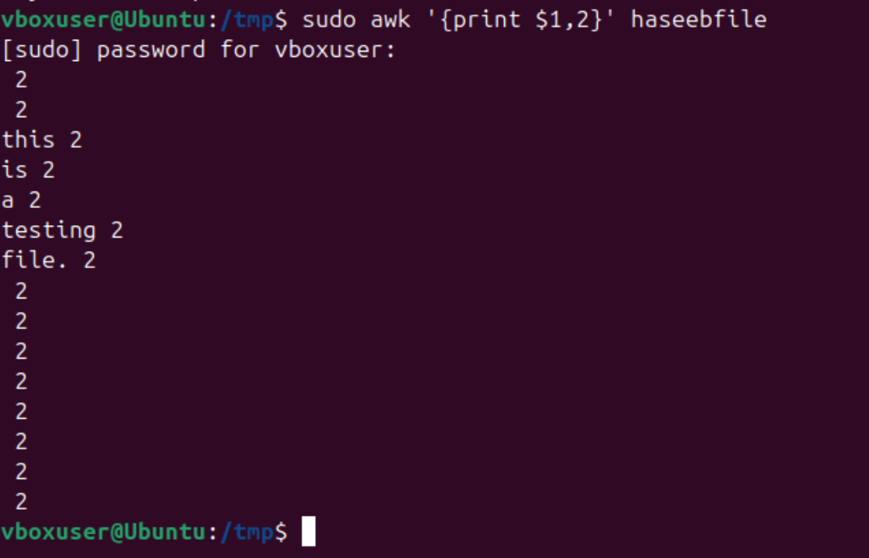

**31. Filter and print lines based on a specific pattern or condition.**

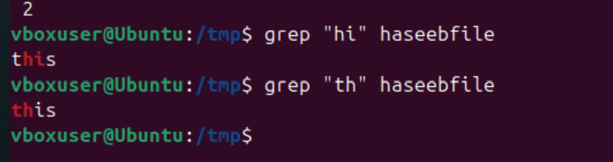

**Perform string manipulation, such as extracting substrings or changing  
case**

